**Configure LinkTool Velocity plugin for Solr Solritas UI (Solr v4.5.1)  
  
The Problem**o The path to each crawled local file-system files is sent to Solr using the unique “id” field, with the path in the “file:/” format. We can see an example using a Solr admin query:  
  
"id": "**file:/D:/Manifold-IN/testcrawlarea1/How%20to%20see%20user-agent%20in%20server%20log%20for%20login%20page.msg**",  
  
o The Solritas Velocity configuration with Solr (V4.5.1) displays each search result document like this:  
  
It would be much clearer if we could display the “Id:” value decoded instead, i.e.:  
**“file:/D:/Manifold-IN/testcrawlarea1/How to see user-agent in server log for login page.msg”**  
(I used <https://meyerweb.com/eric/tools/dencoder/> to decode the string).  
  
o We can see that this “Id:” value being displayed is done here in “example\solr\collection1\conf\velocity\richtext_doc.vm”:  
   
  
o After some research (see the references below), we ***should*** be able to achieve this with the following changes to richtext_doc.vm:  
  
For cut-and-paste:

|  |
| --- |
| ## Row 2?: ID / URL  <div>  ## JeremyC. Id hyperlinked, to try and launch native application.  ##Id: #field('id')  #if($doc.getFieldValue('id'))  #set($id_link = $doc.getFieldValue('id'))  #set($id_link2 = $id_link.replace("file:/","file:///"))  #set($id_decoded = $link.decode($id_link2))  #end  Id: <a href="${id_link2}" target="_blank">${id_decoded}</a>  </div> |

Here we use the “LinkTool” Velocity “tool” to decode the “file:/” url, i.e. replace “%20” with space characters. **However**, this does not work:  


o The LinkTool (and EscapeTool) are implemented in “velocity-tools-2.0.jar” (this is NOT built with the Solr sources). In the jar file:  
org/apache/velocity/tools/generic/EscapeTool.class  
org/apache/velocity/tools/generic/LinkTool.class  
  
If we search the Solr source code for where the “EscapeTool” class is instantiaed:  
  
$ grep -r 'new EscapeTool' *

Solr-4.5.1/solr/contrib/velocity/src/java/org/apache/solr/response/  
**VelocityResponseWriter.java**: context.put("esc", new EscapeTool());

And if we examine this file, we see that there is no similar “new LinkTool”. This must be why our changes to richtext_doc.vm are doing nothing. Fortunately, we CAN rebuild VelocityResponseWriter.java, because it’s part of the Solr sources.File VelocityResponseWriter.java ends up in the Solr jar file **solr-velocity-4.5.1.jar**.  
  
  
**The Solution**Our updated VelocityResponseWriter.java:  
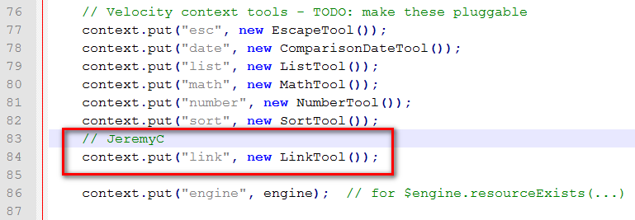  
To now rebuild **solr-velocity-4.5.1.jar**, see my other document “Building Solr.docx”. **Note:** For some reason (currently unknown to me), the built jar is named **solr-velocity-4.5.1-SNAPSHOT.jar**, so I simply renamed it as **solr-velocity-4.5.1.jar** when I copied it to my Solr installation, and it worked fine 😊:  


**References:**o Creating Velocity “tools” such as “EscapeTool” and “LinkTool”:  
<http://velocity.apache.org/tools/2.0/creating-tools.html>

o Another example **richtext_doc.vm**:  
<https://github.com/apache/lucene-solr/blob/master/solr/server/solr/configsets/sample_techproducts_configs/conf/velocity/richtext_doc.vm>

o Velocity “EscapeTool” (aka “esc”):  
<https://velocity.apache.org/tools/2.0/apidocs/org/apache/velocity/tools/generic/EscapeTool.html>

o Velcoty “LinkTool” (aka “link”):  
<https://velocity.apache.org/tools/2.0/apidocs/org/apache/velocity/tools/generic/LinkTool.html>

o Other Velocity 2.0 tools:  
<https://velocity.apache.org/tools/2.0/generic.html>

*JeremyC 5-6-2018***END**